Statement of Work
Watts and Associates County Yield Trends Analysis
Bozeman, Montana
Version: 2.0

Client:
John Kuhling
Watts and Associates

Montana State University Team
Tommy Mellott
Max Taylor
Merlin McKean
Hans Petersen

Advisor:
Dr. Andrew Hill
Department of Agricultural Economics and Economics
Montana State University

________________________________________ ______________
Advisor Date

________________________________________ ______________
Client Date
Background

Watts and Associates (W&A), situated in Billings, Montana, holds a paramount role as a consultant within the agricultural insurance sector. Established by Tim Watts in the 1980s, W&A was conceived with the mission of enhancing the well-being of farmers and ranchers by delivering valuable benefits. The consultancy operates collaboratively with key stakeholders in the field, including the Risk Management Agency (RMA), producer groups, agencies, as well as insurance and reinsurance companies.
The Risk Management Agency, a pivotal division of the United States Department of Agriculture, spearheads the nation's crop insurance industry. It plays a crucial role not only in forecasting expected yields for various crops across their respective growing locations but also in overseeing the Federal Crop Insurance Corporation program, thereby ensuring that crop insurance remains both accessible and affordable to agricultural producers. These forecasts are essential for determining the premiums of subsidized crop revenue insurance plans. In 2023, the RMA was responsible for projecting yields for over 15,000 crop-county combinations, facilitating the calculation of indemnities on more than $16 billion in insurance premiums. The accuracy of these county-specific yield forecasts is critical, impacting both the producers, who rely on these policies for financial protection, and the insurance companies that provide them. Discrepancies in forecasting can lead to significant financial consequences: underpredicted yields may result in inadequate coverage for farmers, while overestimations can trigger extensive indemnity payouts. To mitigate such risks, the RMA provides reinsurance to insurers, ensuring that losses exceeding certain thresholds are managed effectively. This safeguard, however, implicates taxpayer funds, highlighting the need for precise and equitable forecasting practices. The balance RMA seeks to maintain between providing adequate insurance coverage and ensuring fiscal responsibility underscores the agency's vital role in the agricultural sector's resilience.
The challenge this project aims to tackle is to provide an in-depth analysis and evaluation of the county yield predictions to provide Watts and Associates with insights into the overall accuracy and reliability of the RMA’s forecast to best advise their clients. The success of this project will not only benefit producers and insurance companies but will also contribute valuable insights to the broader agricultural community.

Project Objectives

The project encompasses three primary objectives: firstly, to evaluate the historical accuracy of county yield predictions made by the Risk Management Agency; secondly, to assess the predictive capabilities of the model developed by Watts & Associates for county yields; and thirdly, to endeavor in creating a novel model aimed at surpassing predictions made by both the RMA and W&A. Replication of the RMA and W&A models is integral to gaining a comprehensive understanding of the underlying processes and data interpretation. Utilizing the data provided by W&A, which includes corn and soy yields from selected counties, our team will replicate these models. The evaluation of model accuracy will involve out-of-sample testing and the computation of residuals.
The collaborative effort of our team, comprising Merlin McKean, Hans Petersen, Tommy Mellott, and Max Taylor, will be crucial in the creation of our predictive model. Employing the tools at our disposal, the team will strive to minimize residuals, ensuring the development of a model with optimal accuracy.
Stakeholder Needs Assessment

Within the County Yield Trends Analysis project at Watts and Associates, an array of stakeholders with distinct interests and expectations has been identified, each wielding a pivotal role in the project's ultimate success.
The agricultural industry in the concerned counties, encompassing crop producers, end consumers, and intermediary entities, relies heavily on accurate county crop predictions to inform crucial insurance decisions. A consensus prevails on the paramount necessity for precise and reliable information. The alignment of these stakeholders' interests with the project's success is evident, as enhanced accuracy in county crop forecasts directly translates to reduced payments for producers and lower costs for families.
Watts and Associates, under the supervision of John Kuhling, harbor a vested interest in the project's outcome. Their desire for improvements in accuracy and insights into alternative models that may surpass existing Risk Management Agency predictions is paramount. The potential reliability of our alternative model stands to provide W&A with innovative perspectives and the ability to better advise their clients. Mr. Kuhling serves as the sole point of contact at Watts & Associates, streamlining communication and expediting information flow between the project team and the sponsor.
The project team, comprising Tommy Mellott, Merlin McKean, Max Taylor, and Hans Petersen, possesses specific requirements, including access to pertinent data sources, client support for comprehending intricacies, and guidance from the team's advisor, Dr. Andrew Hill. Dr. Hill emphasizes clear communication, adherence to academic standards, and regular updates on project progress in his advisory role. Concurrently, project professor Dr. Faraz Dadgostari expects strict adherence to timelines and the delivery of high-quality outputs. Montana State University, as the overseeing entity, envisions the project as a valuable learning experience, successful integration of academic knowledge into real-world applications, and a positive contribution to the university's reputation through impactful projects.
Recognizing and addressing the diverse needs of these stakeholders is imperative for achieving the objectives of the County Yield Trends Analysis project, ensuring a positive impact on both the academic and agricultural communities involved.

Project Tasks and Deliverables

Accurate forecasting of county crop yields is paramount for the holistic well-being of the agricultural industry. The precision with which crop insurance firms can predict these yields directly influences the premium rates they establish, enabling them to mitigate substantial losses on indemnity payments. Conversely, inaccurate predictions may precipitate overestimation or underestimation of potential losses, resulting in inflated premiums or inadequate coverage. Producers are also heavily reliant on precise predictions. In cases where forecasts overestimate expected yields, farmers may opt for lower coverage levels than necessary, exposing themselves to the risk of insufficient financial protection during actual yield shortfalls. This scenario can leave farmers inadequately compensated for losses incurred during a poor harvest, leading to financial strain and disruptions in farming operations. Conversely, underestimating expected yields may compel farmers to acquire higher coverage levels than needed, resulting in inflated premium costs and an additional financial burden. Such miscalculations can diminish profitability, as farmers may end up paying higher insurance premiums for coverage that surpasses the actual losses experienced. Therefore, a more accurate yield prediction not only safeguards the financial interests of farmers but also serves as a compelling incentive for enhanced crop production.
To comprehend the methodologies employed by the RMA and W&A in predicting county yields, Mr. Kuhling has delineated three sequential phases to be undertaken throughout the project. These phases encompass replicating the RMA forecasting model and assessing its accuracy, replicating the W&A forecasting model and evaluating its accuracy, and crafting a forecasting model designed to surpass the effectiveness of the preceding two models. The subsequent section outlines the specific tasks and corresponding deliverables, along with an estimated timeframe for their completion.
Phase 1 (~35% of total project):
Replicating the RMA forecasting model involves utilizing county yield data provided by Watts & Associates and employing the linear piecewise double-knot spline method. Figure I shows an example of a linear piecewise double-knot spline forecast model. The forecast spans two years from the initial year (1981 in our case), utilizing thirty years of historical county yield data to construct a model with the lowest sum of squared errors (SSE). This process will be repeated for each year from 1981 to 2020, with all forecasts projecting two years ahead. The extrapolation of the forecasted value will be made by extending the slope from the end of the forecast model, and the forecasted county yield will be compared to the actual yield, determining the overall forecast mean squared error (MSE).
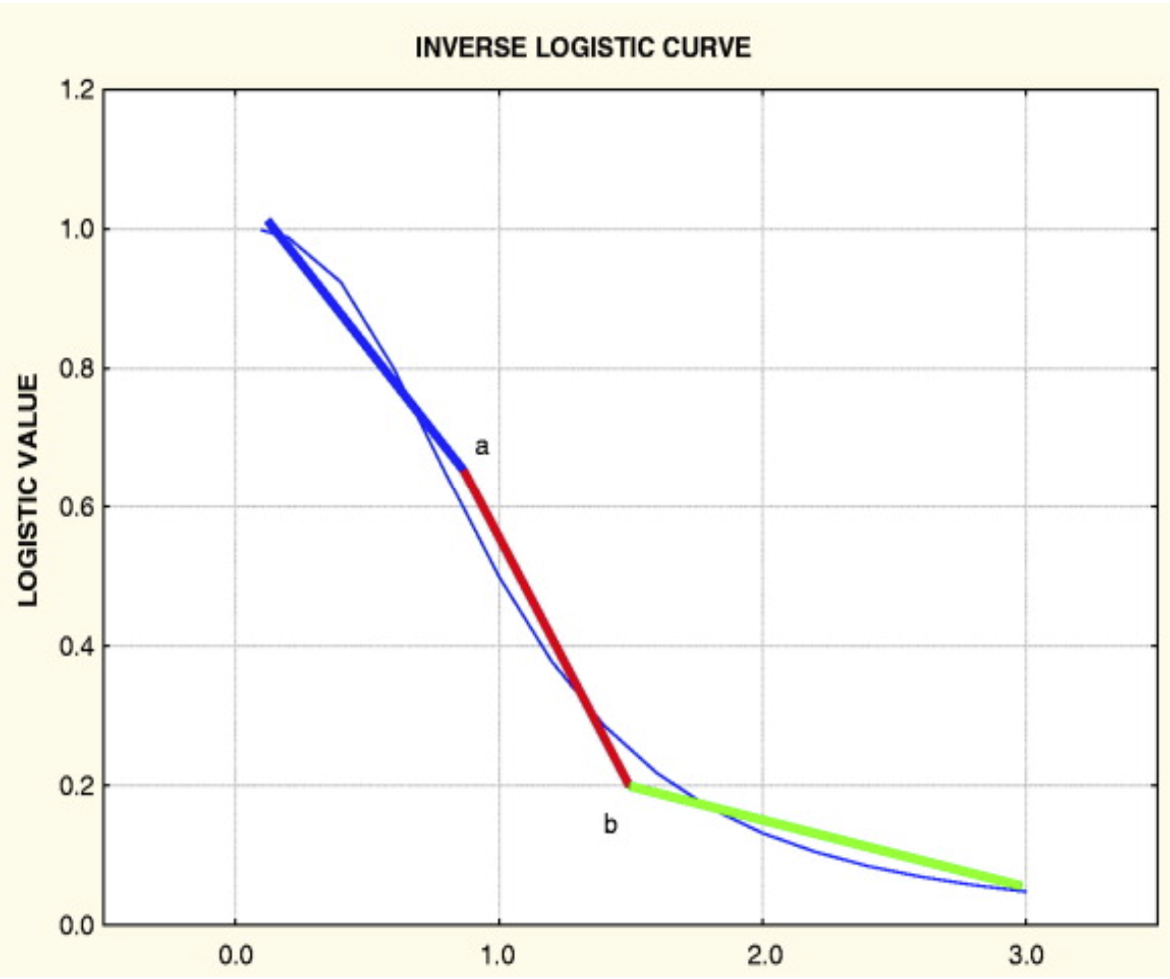
Figure I: An example of a linear piecewise double knot spline forecasting method
Phase 2 (~20% of total project):
In this phase, the team will adapt the piecewise linear double-knot spline forecasting method used by Watts and Associates, which operates on defined risk regions rather than individual counties. An SSE minimized piecewise linear double-knot spline will be created based on the average yield of every county in a defined risk region. Subsequently, for each county within the risk region, the average difference between the yield at the regional level and the county yield will be used to shift the risk region’s forecast to the county level. Similar to phase 1, out-of-sample testing will use data from the preceding 30 years, starting from 1981 and repeating the process annually until 2020. Figure II depicts an example of defined risk regions for Illinois.
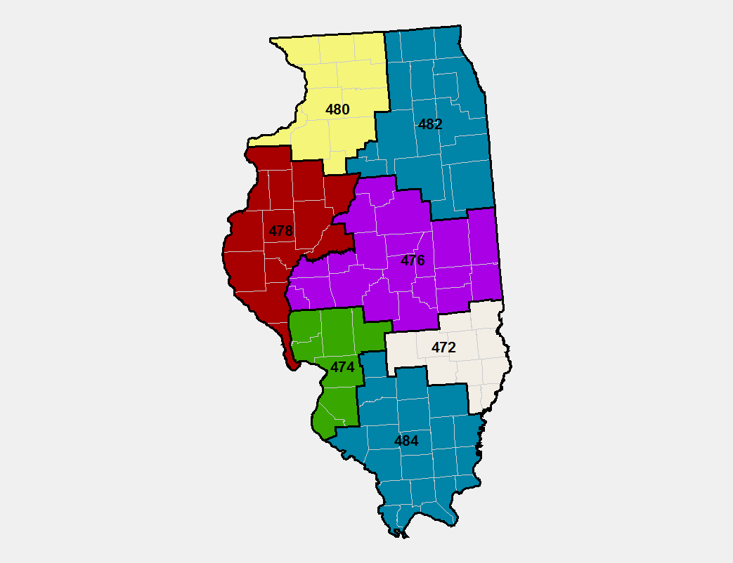
Figure II:. Defined risk regions within Illinois
Phase 3 (~45% of total project):
This phase involves extrapolating from W&A's established forecasting methods, aiming to surpass the RMA's predictions using any desired forecasting method. Meticulous documentation of each method, along with insights gained, is mandated by Mr. Kuhling. The overarching objective is for the team to leverage their expertise in statistics and forecasting to develop an innovative and precise model, aligning with Mr. Kuhling's vision for project success. Figure III represents a Gantt chart, included below to offer an approximate timeline of each of the project’s checkpoints and phases.
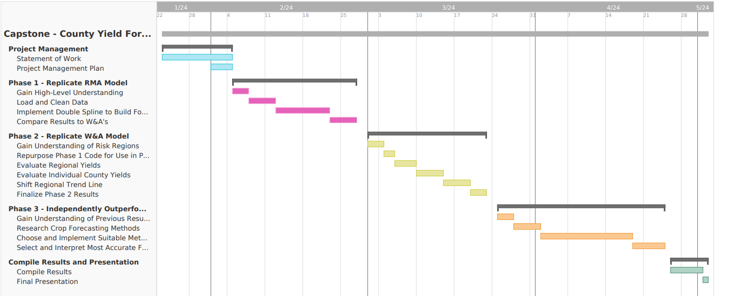
Figure III: Gantt chart for County Yield Forecasting project

Budget

The team plans to meet for approximately five hours a week outside of class time to work on ongoing sprints. This approximation will fluctuate depending on project deadlines and unforeseen setbacks.
As for monetary expenses, the team does not anticipate the project incurring any costs for travel, data collection, or data analysis. If expenses do arise, the team will communicate with W&A and Dr. Hill to follow all steps needed.

Confidentiality
The team will adhere to all confidentiality agreements, outlining intellectual property ownership and the disclosure of company information. Non-disclosure documents will be included, ensuring the protection of client data and information.
This SOW draft will be submitted for review and approval by the project supervisor and course instructor, followed by submission to the project sponsor for final approval.

